**Project Title**

**Team Id:NM2025TMID13569**

**Team Members: 4**

**Team Leader: PRASANTH .M**

**Team Member 1: RITHISHKUMAR .K**

**Team Member 2: BHUVANESHWARAN .K**

**Team Member 3: SADASIVAM .B**

**Problem Statement:**  To address delays and inefficiencies, a ServiceNow Laptop Request Catalog Item is required to standardize and automate laptop requests and fulfillment

**Objective:** The objective of this project is to simplify the laptop request process by implementing a standardized catalog item in ServiceNow, automate approval workflows, improve fulfillment efficiency, and enhance tracking and asset management

**Skills:**  The project team must possess skills in ServiceNow catalog configuration, workflow automation, scripting, ITSM processes, asset management, and effective stakeholder communication.”

**TASK INITIATION**

**Milestone 1 : Update set**

**Activity 1:** **Create Local Update set**

1. Open service now

2. Click on All >>search for update sets

3. Click on new

4. Fill the following details to create a update set as: “Laptop Request”

5. Click on submit and make current

6.By clicking on the button it activates the update set

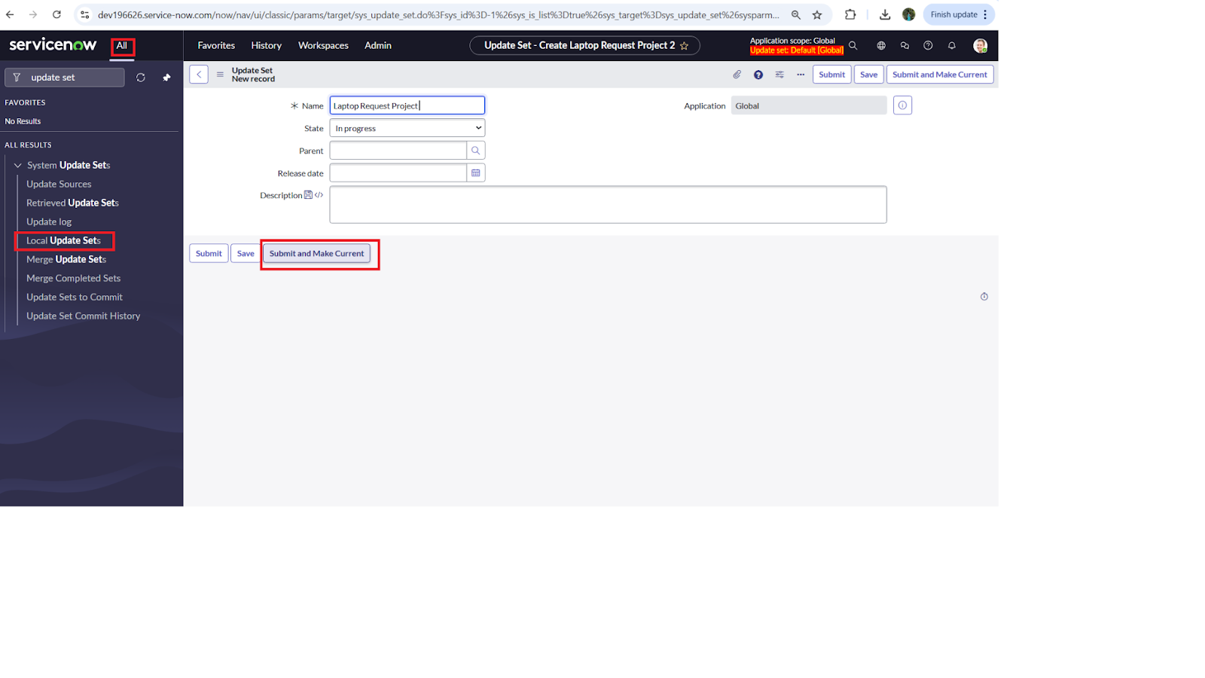

**NOTE: Perform all actions under this newly created update set only.**

**Milestone 2 :**  **Service Catalog Item**

**Activity 1: Create Service Catalog Item**

1. Open service now.

2. Click on All  >> service catalog

3. Select maintain items under catalog definitions

4. Click on New.

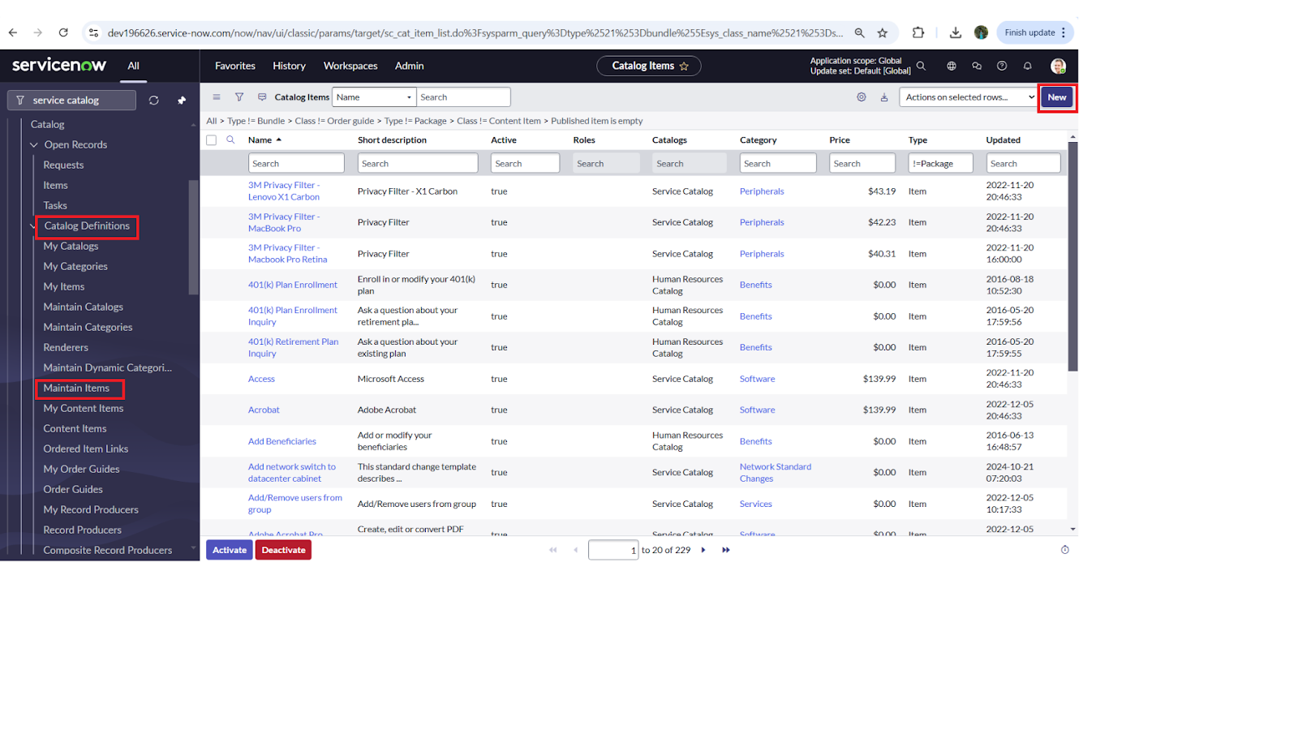

1. Fill the following details to create a new catalog item

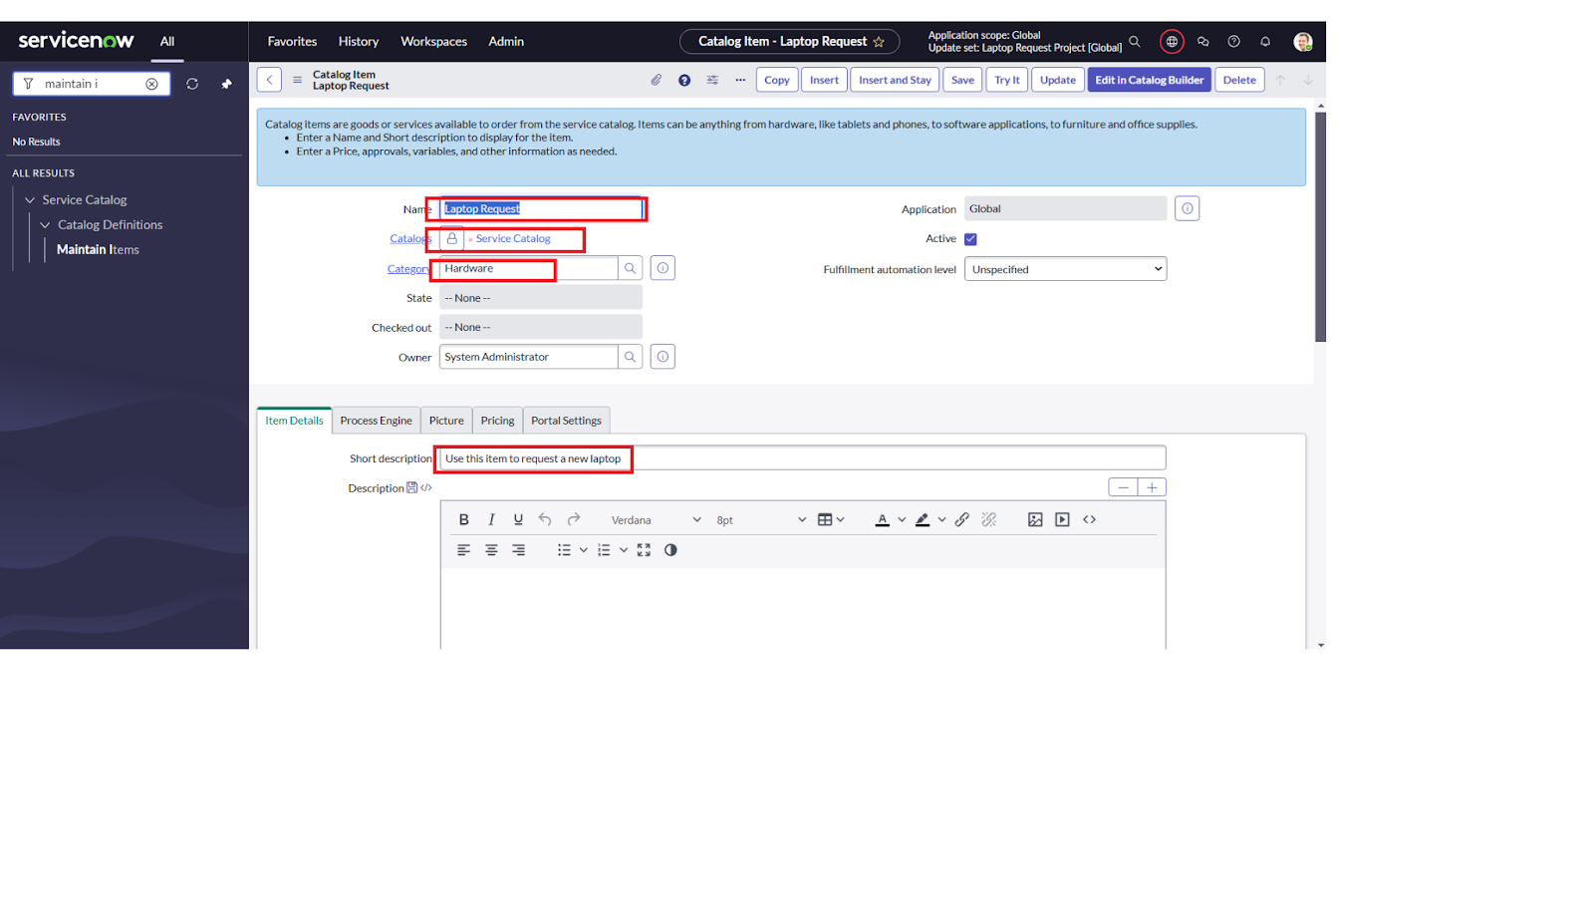

**6. Click on ‘SAVE’**

**Activity 2: Add variables**

**Step1:**

* After saving the catalog item form scroll down and click on variable(related list)
* Click on new and enter the details as below

1. Variable 1:Laptop Model

             Type: Single line text

             Name: laptop_model

             Order:100

* Click on submit
* Again click on new and add Remaining variables in the above process

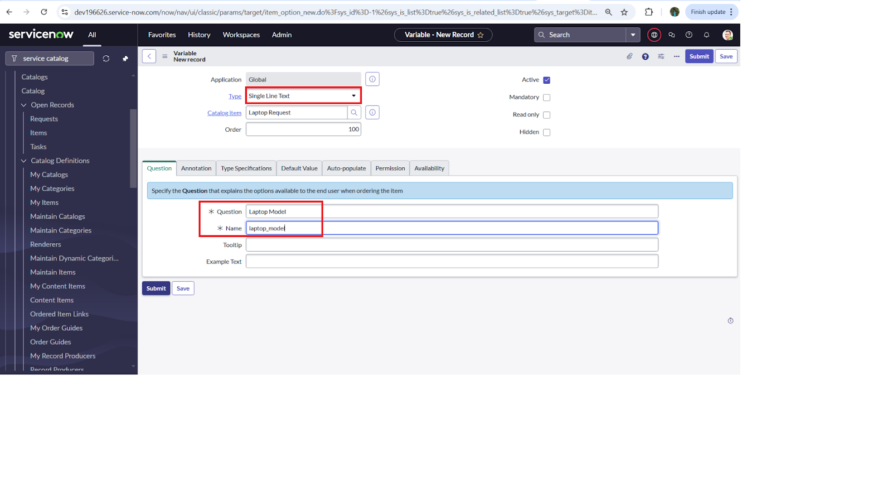

**2. Variable 2:Justification**

**Type: Multi line text**

**Name: justification**

**Order:200**

**3. Variable 3:Additional Accessories**

**Type: Checkbox**

**Name: additional_accessories**

**Order:300**

**4. Variable 4: Accessories Details**

**Type: Multi line text**

**Name:accessories_details**

**Order:400**

**Step1**

* **After adding above variable which are added to newly created catalog item**
* **Then save the catalog item form**

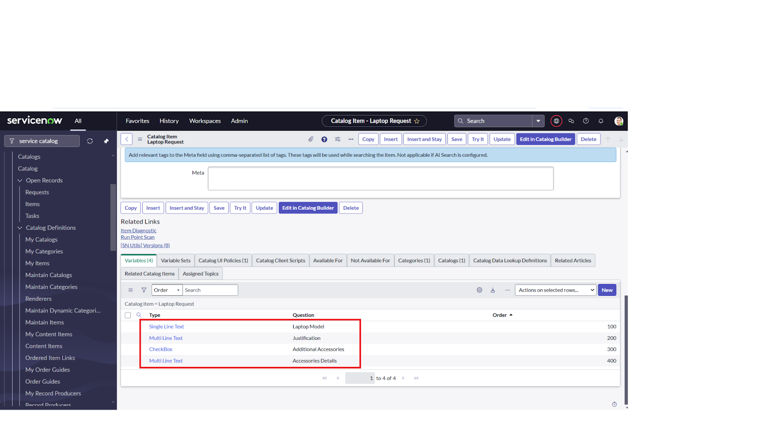

**Milestone 3 : UI Policy**

**Activity 1: Create Catalog Ui policies**

1. Click on all>> search for service catalog
2. Select maintain item under catalog definition
3. Select ‘laptop request’ and scroll down click on “Catalog Ui policies”
4. In the catalog ui policies related list tab click on new
5. Give short description as: show accessories details
6. Set the Catalog Condition in the related list tab ‘when to apply’

                  [field: additional_ accessories, operator: is, value: true]

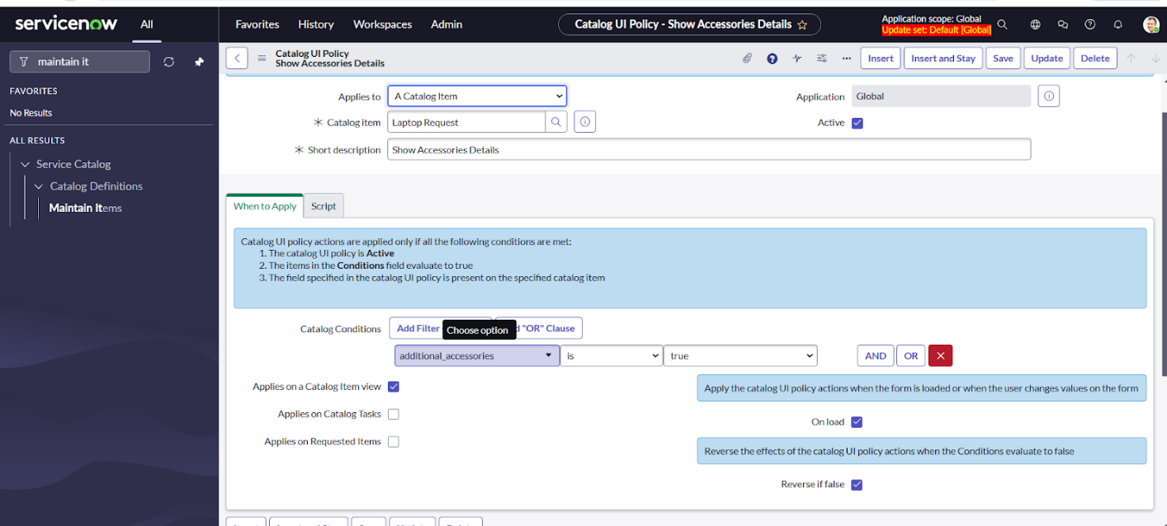

7. Click on **save**.

8. Then click on new button

9. Select variable name as: accessories_details

                              Order:100

                    Mandatory: True

                         Visible : True

10.Click on save and again click save button of the catalog ui policy form

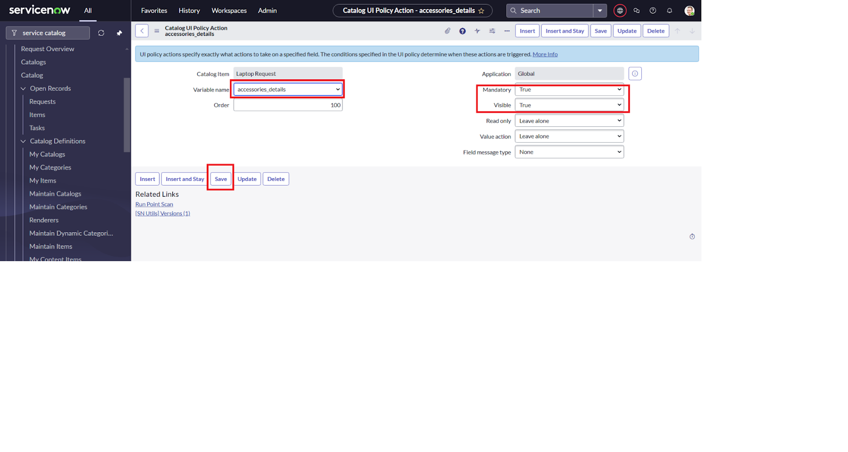

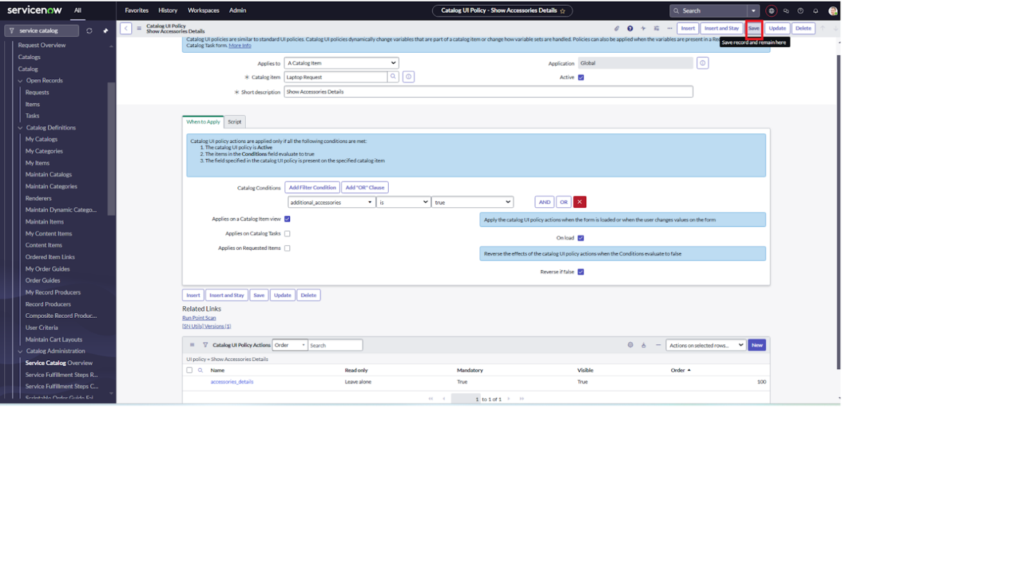

**Milestone 4: UI Action**

**Activity 1: Create ui action**

1. Open service now.

2. Click on All  >> search for ui action

3. Click on new

4. Fill the following details to create ui action

              Table: shopping cart(sc_cart)  
              Order:100  
              Action name:  Reset form  
               Client : checked

Script:  
    function resetForm() {  
    g_form.clearForm(); // Clears all fields in the form  
    alert("The form has been reset.");  
}  
  
Click on save

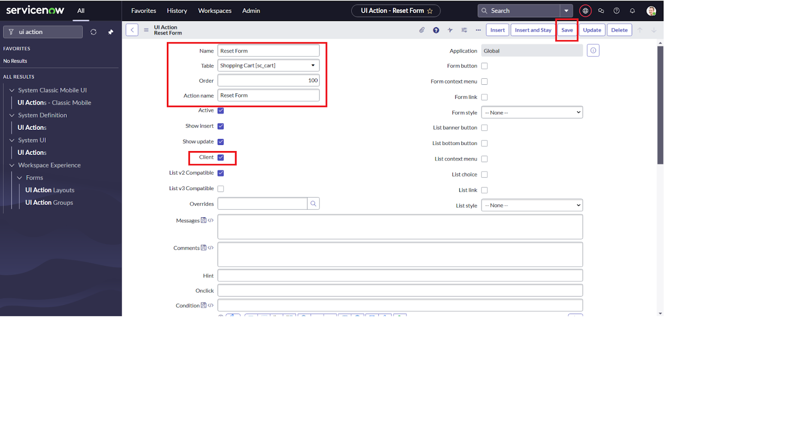

**Milestone 5 : Export Update set**

**Activity 1: Exporting changes to another instances**

1. **Click on All  >> search for update sets**
2. **Select created update set i.e. ‘Laptop Request Project’**
3. **Set the state to ‘Complete’**
4. **In the related list Update tab, updates are visible which we perform under this update set.**
5. **Click on export to XML ,it download one file**

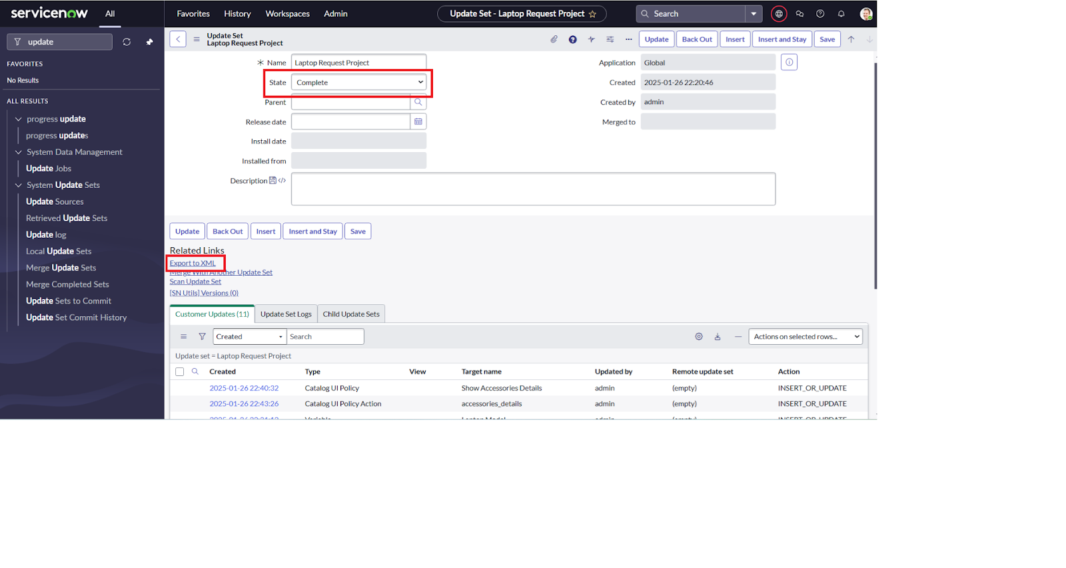

**Milestone 6: Login to another Instance**

**Activity 1: Retrieving the update set**

1. **Click on all>> search for update sets**
2. **Select “Retrieved update set” under system update set**
3. **It open retrieved update set list and scroll down**
4. **Click on Import update set from XML**

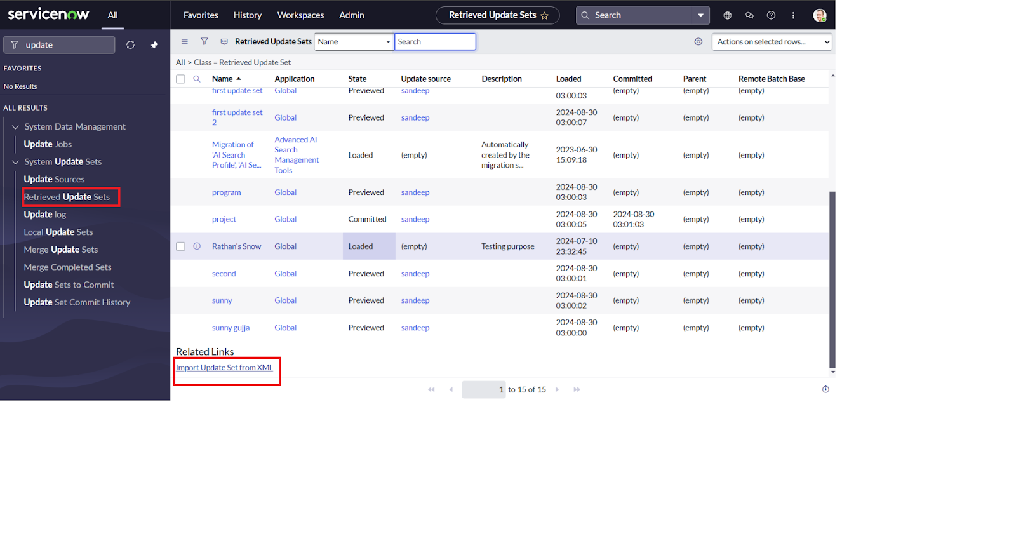

5. Upload the downloaded file in XML file

6. Click on Upload and it gets uploaded.

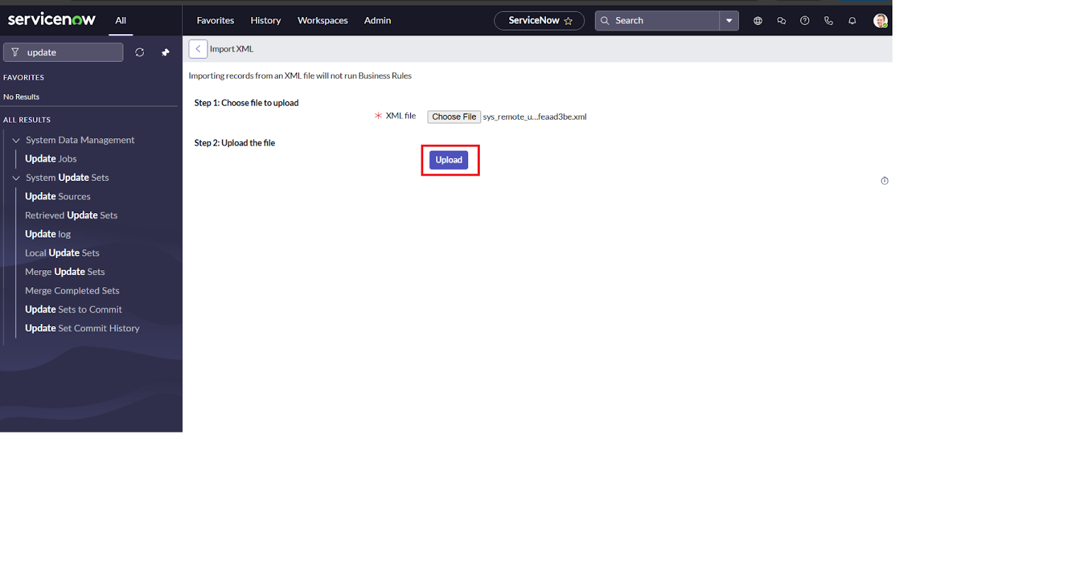

7. Click on preview update set

8. And click on commit update set

9. And also see the related tab updates

10.After commiting update set in this instance we get all updates which are done in the previous instance

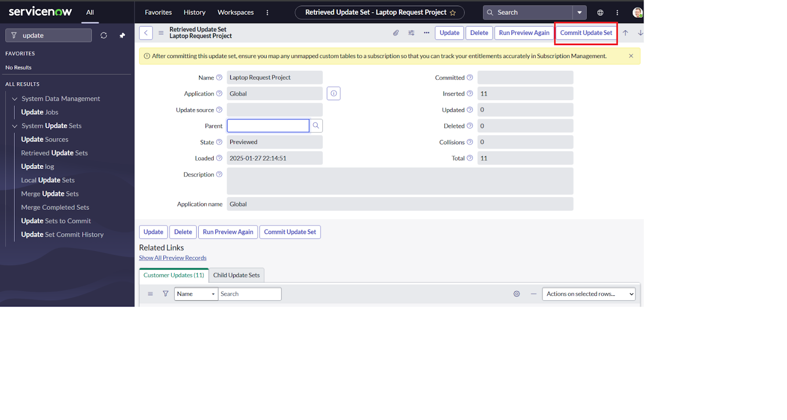

**Milestone 6: Testing**

**Activity 1: Test Catalog Item**

1. Search for service catalog in application navigator in target instance

2. Select  hardware category and search for ‘laptop request’ item

3. Select laptop request item and open  it

4. It shows three variables only

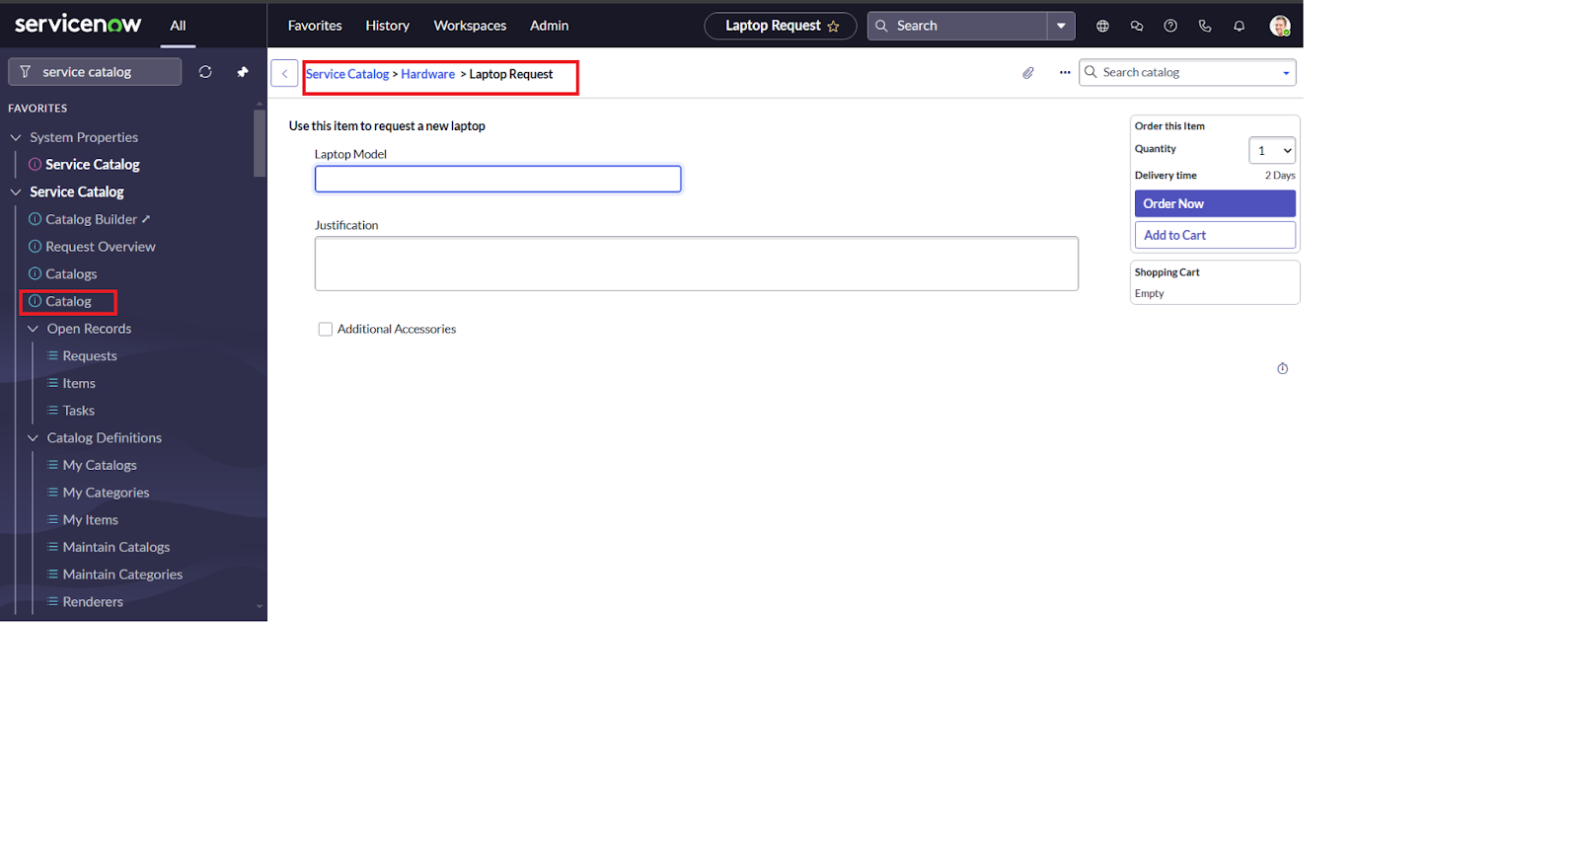

5.Now  see the results,it fulfills our requirements

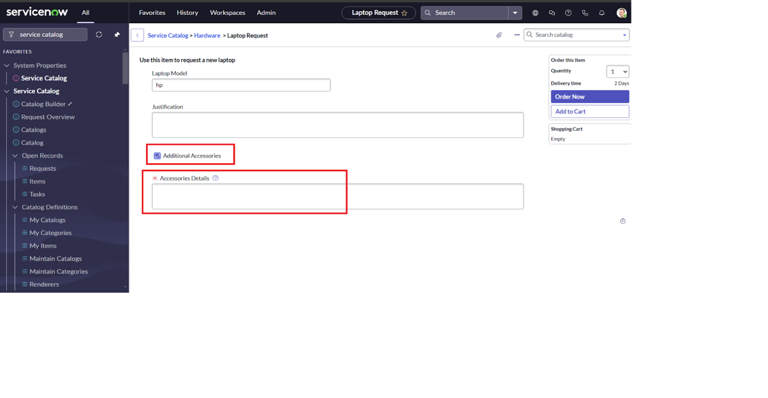

**Conclusion :**

The Laptop Request Catalog Item project successfully streamlines the process of requesting laptops within the organization by leveraging ServiceNow's Service Catalog capabilities. Through the implementation of a dynamic catalog item, the project ensures that users have an intuitive and user-friendly interface, reducing errors and improving efficiency.This project demonstrates how ServiceNow can be used to replace manual, error-prone processes with automated, efficient, and user-centric solutions. It not only improves service delivery but also enhances employee satisfaction by providing a modern and streamlined request experience.